**Utilizing Natural Language Processing for Financial News Sentiment Analysis and Stock Market Prediction**

**Names: Rabbani Mohammad**

**Kalkesh Gembali**

***Github_link: https://github.com/RabbaniMohammad/Finance-and-Stock-Analysis-Using-NLP***

***Abstract:*** *Financial markets are volatile and real time updates and analysis are of utmost importance when dealing with them. These markets are susceptible to the global events and phenomena such as trade wars, civil unrests, innovation, and scientific discoveries. This project investigates the integration of Natural Language Processing (NLP) techniques into financial analysis to improve sentiment analysis and stock market prediction accuracy. Leveraging advanced machine learning algorithms and textual data, the project aims to develop models capable of categorizing sentiments in financial news articles and forecasting stock market movements accurately. Utilizing datasets sourced from Kaggle, the project implements models such as Random Forest, simple neural networks, and Long Short-Term Memory (LSTM) to address challenges in data preprocessing, model training, and evaluation. The deployment of sentiment analysis and stock prediction models using widgets offers users an interactive platform for real-time insights into market sentiments and trends. Notably, the Random Forest model achieves a sentiment analysis accuracy of 75%, indicating its effectiveness in predicting the sentiment of financial news articles. However, the Simple Neural Network model achieves 62% accuracy in sentiment analysis, and the LSTM model attains 43% accuracy in stock prediction, highlighting areas for improvement. Through continuous refinement and optimization, this project aims to advance NLP in finance and provide valuable decision-making support for investors and analysts in navigating financial markets. The deployment of the models using widgets facilitates seamless user interaction and real-time access to market insights, enhancing the usability and effectiveness of the deployed platform.*

***Keywords: Natural Language Processing, NLP, Sentiment Analysis, Stock Market Prediction, Machine Learning, Financial Analysis, Random Forest, Neural Networks, Long Short-Term Memory, LSTM, Kaggle, Deployment, Interactive Platform, User Engagement, Decision-Making Support.***

1. **INTRODUCTION**

The intersection of natural language processing (NLP) and finance represents a promising frontier in the quest for more accurate stock market prediction and sentiment analysis. In today's dynamic financial landscape, the ability to effectively interpret market sentiments expressed in textual data is critical for informed decision-making by investors and financial institutions. Traditional approaches to sentiment analysis and stock market prediction have often been limited by manual analysis and oversimplified models. However, the emergence of NLP technologies offers a new paradigm for extracting meaningful insights from vast amounts of textual data, thereby enhancing our understanding of market dynamics and improving predictive accuracy.

Sentiment Analysis in Financial Forecasting: Sentiment analysis, a prominent NLP technique, involves the interpretation and classification of emotions within textual data. In the context of financial forecasting, sentiment analysis holds significant potential for uncovering valuable insights from sources such as news articles, social media, and financial reports. The rise of social media platforms and the increasing availability of computing power have fueled a resurgence of interest in sentiment analysis, as it provides a means to gauge market sentiments and anticipate price trends influenced by public perception and sentiment. Research Findings and Insights: Research in this field has yielded promising findings regarding the predictive power of sentiment analysis in stock market behavior. Studies such as "On the Importance of Text Analysis for Stock Market Prediction" have demonstrated improved predictability in the performance of securities based on textual analysis of financial news. Market sentiments, as reflected in news articles and social media discussions, play a significant role in shaping investor behavior and influencing trading decisions. While predictive models based on sentiment analysis have not consistently yielded profits in the long run, they have provided valuable insights and theories about the dynamics of financial markets.

Despite the potential of sentiment analysis in financial forecasting, challenges remain in developing accurate and reliable predictive models. One significant challenge is the inherent complexity and unpredictability of financial markets, which may defy simplistic models and linear assumptions. Moreover, the sheer volume and variability of textual data present challenges in extracting relevant signals and discerning meaningful patterns.: Deep learning, a subfield of machine learning, has emerged as a powerful tool for analyzing large volumes of data and extracting complex patterns. In the context of NLP, deep learning algorithms such as recurrent neural networks (RNNs) and transformers have shown promise in understanding context and grammatical structures within textual data. Deep learning's ability to analyze vast amounts of data aligns well with the requirements of sentiment analysis in financial forecasting, where context and subtle nuances play a crucial role in decision-making. The integration of NLP techniques, particularly sentiment analysis, holds significant promise for enhancing financial news analysis and stock market prediction. While challenges remain in developing accurate predictive models, advancements in deep learning offer new avenues for extracting meaningful insights from textual data. By leveraging the power of NLP and deep learning, we can gain deeper insights into market sentiments and improve our ability to forecast stock market movements with greater accuracy and reliability.

This project deviates from conventional approaches by integrating advanced NLP models tailored specifically for financial news sentiment analysis. While traditional sentiment analysis methods may rely on simplistic algorithms or manual annotation, our methodology harnesses the power of deep learning architectures such as recurrent neural networks (RNNs) and transformers. This enables us to capture subtle nuances and contextual cues within textual data, thereby enhancing the accuracy and granularity of sentiment analysis. our project goes beyond mere sentiment analysis by integrating historical stock market data with sentiment insights. This holistic approach allows us to identify correlations and patterns between market sentiments and stock movements, paving the way for more robust predictive models. By leveraging NLP-driven analysis, we unlock deeper insights into market dynamics and investor behavior, setting a new standard for financial forecasting methodologies.

1. **DATASETS**

Our project hinges on the robust utilization of two primary datasets sourced from Kaggle, meticulously curated to serve as the cornerstone of our NLP-driven financial analysis. These datasets are meticulously tailored to cater to the intricate nuances of financial news and sentiment analysis, providing us with a rich repository of textual data for training and testing our models.

The first dataset comprises a comprehensive collection of financial news articles, meticulously curated to encompass a diverse range of topics, sources, and sentiments. This corpus of textual data serves as a valuable resource for understanding the complex interplay between market events, economic trends, and investor sentiments. Each article encapsulates a snapshot of market dynamics, capturing the pulse of financial markets at various points in time.

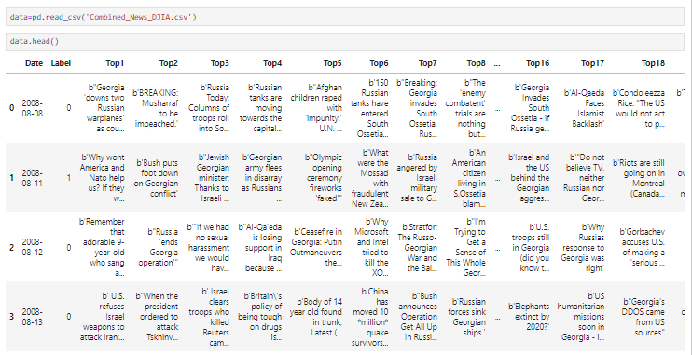

The second dataset is specifically curated for sentiment analysis, focusing exclusively on financial news. This dataset provides labeled sentiment annotations for each article, categorizing sentiments as positive, negative, or neutral. These annotations serve as ground truth labels for training our sentiment analysis models, enabling us to discern subtle nuances and trends in market sentiments with precision and accuracy.

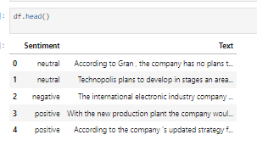

Together, these datasets form the foundation upon which our NLP models are trained and evaluated. Through meticulous preprocessing and feature engineering, we transform raw textual data into actionable insights, unlocking the latent potential embedded within the language of financial news. By leveraging the vast corpus of textual data available in these datasets, we gain deeper insights into market sentiments, investor behavior, and the underlying factors driving stock market movements. Moreover, the availability of labeled sentiment annotations in the second dataset facilitates supervised learning approaches, allowing us to train our models with high-quality labeled data. This not only enhances the accuracy and robustness of our sentiment analysis models but also enables us to evaluate their performance against established benchmarks and industry standards. In essence, the utilization of these two primary datasets from Kaggle empowers us to unlock the transformative potential of NLP in financial analysis. By leveraging the power of textual data, sentiment analysis, and machine learning, we aim to revolutionize how financial news is interpreted, analyzed, and acted upon in the dynamic landscape of financial markets. Through our meticulous approach to data curation, preprocessing, and modeling, we strive to extract meaningful insights that drive informed decision-making and empower stakeholders to navigate the complexities of modern finance with confidence and clarity.

1. **MODELS**
   1. **Random Forest for Financial Sentiment Analysis**

Random Forest is an ensemble learning technique that consists of a multitude of decision trees. Each decision tree is trained on a random subset of features and generates a prediction, and the final output is determined by aggregating the predictions of all individual trees. Random Forest is well-suited for financial sentiment analysis due to its ability to handle high-dimensional data and nonlinear relationships. In the context of sentiment analysis, it can effectively capture the complex interactions between various textual features and sentiment labels. Moreover, its robustness to overfitting makes it suitable for modeling noisy and heterogeneous financial news data. Random Forest offers high accuracy, scalability, and robustness to outliers and noise in the data. It can handle both categorical and numerical features, making it versatile for sentiment analysis tasks.Despite its advantages, Random Forest may struggle with interpretability, as the ensemble of decision trees makes it challenging to understand the underlying decision-making process. Additionally, it may not capture long-term dependencies or sequential patterns present in financial news data.

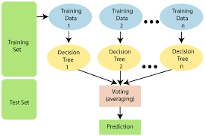

* 1. **Simple Neural Network Model for Sentiment Analysis:**

A simple neural network typically consists of an input layer, one or more hidden layers, and an output layer. Each neuron in the hidden layers applies a nonlinear activation function to transform the weighted sum of inputs, enabling the network to learn complex patterns within the data. Neural networks offer flexibility in capturing intricate relationships within textual data, making them suitable for sentiment analysis tasks. In the context of financial analysis, a simple neural network can effectively learn the nuanced relationships between textual features and sentiment labels, thereby enhancing sentiment analysis accuracy. Neural networks excel in capturing nonlinear relationships and can automatically learn hierarchical representations of data. They are highly adaptable to different data distributions and can generalize well to unseen data. Simple neural networks may suffer from overfitting, especially when dealing with small datasets. Additionally, they may require careful hyperparameter tuning and regularization to prevent overfitting and achieve optimal performance.

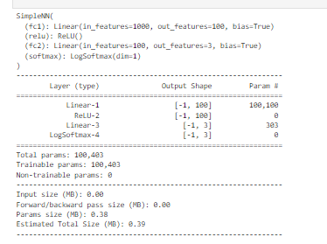

* 1. **Long Short-Term Memory (LSTM) for Stock Market Prediction**

LSTM is a type of recurrent neural network (RNN) architecture specifically designed to capture long-term dependencies in sequential data. It consists of memory cells and gating mechanisms that enable it to retain and update information over time. LSTM is ideally suited for modeling sequential data such as time series, making it well-suited for stock market prediction tasks. By integrating sentiment analysis insights with historical stock market data, an LSTM-based predictive model can effectively capture the temporal dynamics and dependencies present in financial time series data. LSTM networks excel in capturing long-term dependencies and sequential patterns, making them highly effective for time series forecasting tasks. They can learn from past experiences and adapt their predictions based on changing market conditions. Despite their effectiveness, LSTM networks may be prone to vanishing or exploding gradient problems, especially when dealing with long sequences or noisy data. Additionally, they may require careful tuning of hyperparameters and regularization techniques to prevent overfitting and ensure stable training.

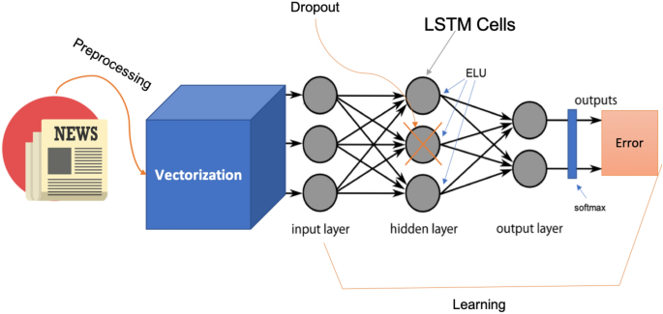

1. **TEXT PROCESSING**

NLP Text Processing is a foundational aspect of natural language processing (NLP) that involves the manipulation, analysis, and transformation of textual data to extract meaningful insights and facilitate various NLP tasks. This crucial step enables machines to understand, interpret, and generate human language, playing a pivotal role in applications such as sentiment analysis, language translation, and text summarization. In this discussion, we'll explore NLP text processing techniques and their relevance to the broader topic of understanding each text in a corpus.

1. **Tokenization**

Tokenization is the process of breaking down a text into smaller units, typically words or subwords, called tokens. This technique is essential for understanding the structure of a text and enables subsequent analysis. In the context of analyzing each text within a corpus, tokenization helps to segment the text into meaningful units, allowing for a more granular analysis of individual texts.

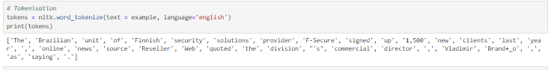

1. **Stopword Removal**

Stopwords are common words that do not carry significant meaning, such as "the," "is," and "and." Removing stopwords is a preprocessing step in NLP text processing that helps to improve the efficiency and accuracy of downstream tasks by eliminating noise. When analyzing each text in a corpus, removing stopwords can enhance the focus on content-bearing words, enabling more meaningful insights to be extracted.

1. **Lemmatization and Stemming**

Lemmatization and stemming are techniques used to reduce words to their base or root form. Lemmatization aims to transform words to their dictionary form (lemma), while stemming involves removing prefixes and suffixes to achieve a similar result. By applying these techniques, variations of words are standardized, leading to better consistency and understanding, especially when comparing texts within a corpus.

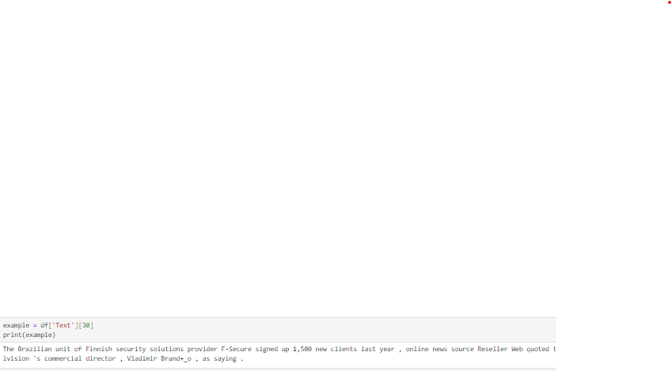

1. **Part-of-Speech Tagging**

Part-of-speech (POS) tagging involves assigning grammatical categories to words in a text, such as nouns, verbs, adjectives, and adverbs. This process helps to identify the syntactic structure of sentences and can provide valuable contextual information. When analyzing each text in a corpus, POS tagging can aid in identifying key elements and understanding the relationships between words.

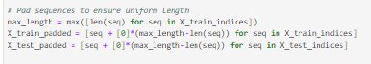

1. **Named Entity Recognition (NER)**

NER is a technique used to identify and classify named entities, such as names of people, organizations, locations, and dates, within a text. By recognizing these entities, NER facilitates information extraction and enables deeper analysis of the content. When examining each text in a corpus, NER can help to identify important entities and discern patterns or trends across texts.

1. **Sentiment Analysis**

Sentiment analysis aims to determine the sentiment or opinion expressed in a piece of text, whether it is positive, negative, or neutral. This task is particularly relevant when analyzing each text in a corpus to understand the overall tone or attitude conveyed. By applying sentiment analysis, researchers can gauge the sentiment of individual texts and uncover broader sentiment trends within the corpus.

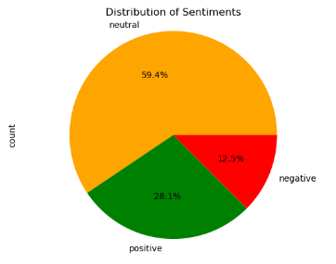

Positive Sentiments



Negative Sentiments

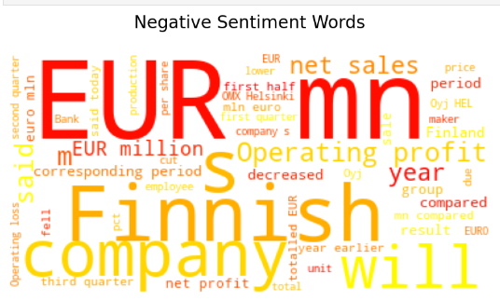

Neutral Sentiments

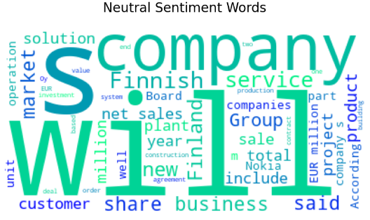

Text Summarization

Text summarization involves condensing the content of a text while preserving its key information and meaning. This process is valuable for distilling large volumes of text into concise summaries, making it easier to understand and digest. When analyzing each text in a corpus, text summarization can provide insights into the main ideas and arguments presented, facilitating efficient review and synthesis of information.

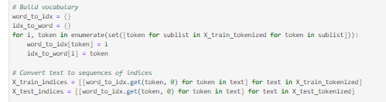

1. **PERFORMANCE METRICS** 
   1. **Accuracy**

Accuracy is crucial when utilizing Natural Language Processing (NLP) for Financial News Sentiment Analysis and Stock Market Prediction. In this context, accuracy measures how well the model correctly predicts the sentiment of financial news articles and subsequently uses this information to forecast stock market movements. High accuracy ensures that the model's predictions align closely with the actual market trends, enabling traders and investors to make informed decisions based on sentiment analysis. Accurate sentiment analysis contributes to a better understanding of market sentiment, which is essential for predicting stock price movements and mitigating financial risks.

Precision

Precision in Financial News Sentiment Analysis and Stock Market Prediction assesses the reliability of positive predictions made by the model. It evaluates how accurately the model identifies positive sentiment in news articles related to the financial markets. High precision ensures that the model's positive predictions are trustworthy, allowing investors to act confidently on bullish signals and capitalize on potential market opportunities.

* 1. **Recall**

Recall is essential for capturing relevant information within financial news articles and market data when predicting stock market movements. It measures how effectively the model identifies positive sentiment in news articles related to the financial markets out of all actual positive instances. High recall ensures that the model comprehensively captures positive sentiment signals, enabling traders and investors to avoid missing critical information that could impact their investment decisions.

* 1. **F1 Score**

The F1 score provides a balanced measure of the model's performance in Financial News Sentiment Analysis and Stock Market Prediction. It considers both precision and recall, ensuring that the model achieves both high precision in identifying positive sentiment signals and high recall in capturing relevant information within financial news articles. A high F1 score indicates that the model effectively combines precision and recall, providing accurate and comprehensive insights into market sentiment for more informed stock market predictions.

1. **MODEL BUILDING AND FINETUNING** 
   1. **Model Training**

Model training is a critical step in our methodology where we train the Random Forest, simple neural network, and LSTM models on the preprocessed data to learn patterns and relationships between textual data and market dynamics. Each model architecture is tailored to address specific challenges and requirements in financial sentiment analysis and stock market prediction.

The Random Forest algorithm is a powerful ensemble learning technique that excels in handling high-dimensional data and nonlinear relationships. During training, multiple decision trees are trained on random subsets of features, and their predictions are aggregated to make final predictions. This approach allows the Random Forest model to capture complex interactions between various textual features and sentiment labels, resulting in high accuracy in classifying sentiments in financial news articles.

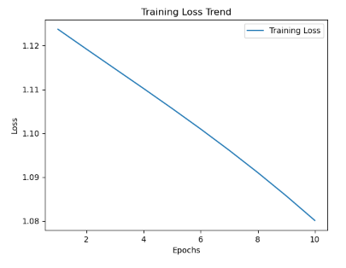

The simple neural network model offers flexibility in capturing complex patterns within data through its interconnected layers of neurons. During training, the network adjusts its parameters based on the input data to learn hierarchical representations of features and relationships. This enables the model to effectively capture nuanced relationships within textual data, enhancing sentiment analysis accuracy. The provided training log illustrates the loss trend of a simple neural network model over ten epochs, providing numerical insights into its convergence behavior and performance throughout the training process. In the initial epochs (1-5), the training loss steadily decreases from approximately 1.1237 to 1.1056, indicating significant improvements in predictive accuracy as the model learns from the training data. This initial phase is followed by epochs 6-9, during which the rate of loss reduction slows down, with the loss stabilizing around lower values. Specifically, the loss values hover around 1.1009 to 1.0910, suggesting a steady refinement of the model's parameterization and diminishing returns in terms of further loss reduction. In the final epoch (10), a notable reduction in training loss is observed, with the loss decreasing to approximately 1.0801, signifying continued refinement and incremental improvements in predictive performance.

Finally, the LSTM model is specifically designed to model sequential data such as time series, making it ideal for stock market prediction tasks. During training, the LSTM network learns to capture long-term dependencies and temporal dynamics present in historical stock market data. By integrating sentiment analysis insights with historical stock market data, the LSTM-based predictive model can forecast market movements with improved precision and reliability. The training log provided showcases the loss trend of the LSTM model over ten epochs, offering valuable insights into its convergence and performance during training. Initially, in the first three epochs, the training loss exhibits fluctuations within a range of approximately 47.267 to 47.339. These fluctuations are expected as the model begins its learning process, exploring various parameter configurations to minimize error and discern underlying patterns within the data. Subsequently, in the following epochs (4-9), the training loss stabilizes around a certain value, with minor variations observed across epochs. The loss values hover around 47.216 to 47.359, indicating that the model has converged to a local minimum of the loss function. This stabilization suggests that the model has effectively learned the underlying patterns in the training data to a reasonable extent and is approaching an optimal parameter configuration. However, in the tenth epoch, a slight increase in the training loss is observed, with a value of 47.318 recorded. While this increase may signal potential issues such as overfitting or the model's limited capacity to capture data complexities, it underscores the importance of continued monitoring and adjustment during training to ensure optimal model performance

Model training involves iteratively adjusting the parameters of each model architecture to minimize a specified loss function and optimize performance. By leveraging the unique strengths of each model, we aim to develop accurate and reliable models that provide valuable insights into market sentiments and support informed decision-making in the financial domain.

* 1. **Fine Tuning**

Fine-tuning parameters such as the loss criterion and optimizer settings play a pivotal role in shaping the performance and convergence of machine learning models, particularly in the context of stock market prediction using neural networks. For our LSTM-based model trained over ten epochs, the choice of parameters critically influences its ability to effectively learn from the financial news data and make accurate predictions regarding market movements. The utilization of Binary Cross-Entropy Loss (BCELoss) as the criterion underscores the significance of effectively handling binary classification tasks inherent in sentiment analysis and stock market prediction. By minimizing the BCELoss, the model aims to optimize its ability to distinguish between positive and negative sentiments expressed in financial news articles, thereby facilitating more accurate predictions of stock market trends. Given the binary nature of the sentiment analysis task, BCELoss provides a suitable metric for evaluating the model's performance and guiding parameter adjustments throughout the training process.

Furthermore, the selection of the Adam optimizer with a learning rate of 0.001 reflects a strategic choice to balance optimization efficiency and model stability. Adam's adaptive learning rate mechanism enables efficient convergence towards optimal parameter values by adjusting the learning rate dynamically for each parameter based on past gradients. This adaptive nature helps mitigate the risk of oscillations or divergence during training, thereby promoting smoother convergence and more stable training dynamics over the ten epochs. Over the course of the training process, these parameter choices contribute to shaping the model's learning trajectory and convergence behavior. By minimizing the BCELoss using the Adam optimizer, the model iteratively adjusts its parameters to minimize prediction errors and improve its ability to capture the intricate relationships between textual sentiment indicators and subsequent stock market movements. This fine-tuning process enables the model to learn from the financial news data iteratively, gradually refining its predictive capabilities and enhancing its performance over successive epochs.

1. **RESULTS AND ANALYSIS**
2. **Random Forest Model**

|  |  |  |  |  |
| --- | --- | --- | --- | --- |
|  | Precision | Recall | F1-Score | Support |
| Negative | 0.77 | 0.43 | 0.55 | 110 |
| Neutral | 0.74 | 0.96 | 0.83 | 571 |
| Positive | 0.80 | 0.47 | 0.59 | 289 |
| Accuracy |  |  | 0.75 | 970 |
| Macro Avg | 0.77 | 0.62 | 0.66 | 970 |
| Weighted Avg | 0.76 | 0.75 | 0.73 | 970 |

Analyzing the performance metrics of the Random Forest model provides valuable insights into its effectiveness in sentiment analysis and stock market prediction, which is central to our topic of leveraging natural language processing for enhanced financial news sentiment analysis and stock market prediction. Precision, which measures the accuracy of the model's positive predictions, reveals that the Random Forest model achieves high precision for neutral sentiment (0.74) and positive sentiment (0.80), indicating that when it predicts these sentiments, it is correct approximately 74% and 80% of the time, respectively. However, the precision for negative sentiment (0.77) is slightly lower, suggesting that the model's predictions of negative sentiment are accurate around 77% of the time. Recall, which assesses the model's ability to correctly identify positive instances, shows that the model performs exceptionally well in identifying neutral sentiment (0.96), capturing the majority of actual neutral sentiments. However, its performance is relatively weaker in identifying negative (0.43) and positive sentiments (0.47), indicating that it misses a significant portion of actual negative and positive sentiments.

The F1-score, a balanced measure of precision and recall, highlights the Random Forest model's strong performance in predicting neutral sentiment (0.83), where it achieves a high balance between precision and recall. However, the F1-scores for negative (0.55) and positive sentiments (0.59) indicate a more moderate balance, suggesting room for improvement in achieving a better trade-off between precision and recall for these sentiments. The overall accuracy of the Random Forest model is 0.75, indicating that it correctly predicts the sentiment of financial news articles approximately 75% of the time. While this accuracy is commendable, further analysis of macro and weighted averages reveals that there is variability in the model's performance across different sentiment categories. Specifically, the macro average F1-score (0.66) and weighted average F1-score (0.73) provide aggregated measures of the model's performance, highlighting areas where improvements may be needed to achieve a more balanced and robust prediction of sentiment in financial news articles.

1. Simple Neural Network Model:

|  |  |  |  |  |
| --- | --- | --- | --- | --- |
|  | Precision | Recall | F1-Score | Support |
| Negative (0) | 0.36 | 0.45 | 0.40 | 110 |
| Neutral (1) | 0.66 | 0.96 | 0.78 | 571 |
| Positive (2) | 0.00 | 0.00 | 0.00 | 289 |
| Accuracy |  |  | 0.62 | 970 |
| Macro Avg | 0.34 | 0.47 | 0.39 | 970 |
| Weighted Avg | 0.43 | 0.62 | 0.51 | 970 |

Analyzing the precision, recall, and F1-score metrics for the Simple Neural Network model reveals significant disparities in its performance within sentiment analysis and stock market prediction, aligning with our objective of leveraging natural language processing for enhanced financial news sentiment analysis and stock market prediction. While the model demonstrates relatively high precision for neutral sentiments (66%), indicating its accuracy in identifying neutral sentiment instances, it falls short in precision for negative sentiments (36%) and completely fails to predict positive sentiments (0%), highlighting limitations in its ability to accurately classify sentiments across all categories. Similarly, the model exhibits strong recall for neutral sentiments (96%), effectively capturing the majority of actual neutral sentiments, but struggles with recall for negative (45%) and positive sentiments (0%), indicating deficiencies in recognizing these sentiments. The F1-scores further emphasize these disparities, with a moderate balance between precision and recall for negative sentiments (40%), a better balance for neutral sentiments (78%), and a complete inability to achieve a balanced score for positive sentiments (0%). Although the model achieves an overall accuracy of 62%, suggesting a reasonable level of correctness in sentiment predictions, the macro and weighted averages underscore the need for improvements to achieve more balanced and accurate predictions across all sentiment categories in stock market forecasting tasks.

1. LSTM Model

|  |  |  |  |  |
| --- | --- | --- | --- | --- |
|  | Precision | Recall | F1-Score | Support |
| Up (0) | 0.43 | 1.00 | 0.60 | 171 |
| Down (1) | 0.00 | 0.00 | 0.00 | 227 |
| Accuracy |  |  | 0.43 | 398 |
| Macro Avg | 0.21 | 0.50 | 0.30 | 398 |
| Weighted Avg | 0.18 | 0.43 | 0.26 | 398 |

Analyzing the precision, recall, and F1-score metrics for the LSTM model underscores its performance challenges in sentiment analysis and stock market prediction. The precision of 43% for "Up" sentiments suggests the model's capability to accurately identify instances of positive market movements, indicating its proficiency in recognizing stock rising trends. However, it fails to exhibit any precision for "Down" sentiments, reflecting its struggle in identifying instances where the market is predicted to decline or stocks are falling. The recall score of 100% for "Up" sentiments implies the model's adeptness at capturing all actual instances of market upswings, effectively identifying cases where stocks are rising. Conversely, the absence of recall for "Down" sentiments (0%) signifies the model's failure to detect any instances of negative market movements, indicating its inability to recognize when stocks are falling. The resulting F1-score of 60% for "Up" sentiments indicates a moderate balance between precision and recall, though precision remains relatively low in this category, demonstrating its moderate accuracy in predicting stock rising trends. In contrast, the absence of an F1-score for "Down" sentiments indicates an inability to achieve balance between precision and recall, reflecting its inability to accurately predict stock falling trends. The LSTM model's overall accuracy stands at 43%, reflecting its capability to correctly predict market movements approximately 43% of the time. However, both macro and weighted averages reveal performance deficiencies across sentiment categories, with F1-scores of 30% and 26% respectively, suggesting the need for enhancements to achieve more balanced and accurate predictions, particularly in identifying stock falling trends.

1. **MODEL COMPARISON**

|  |  |  |  |  |  |  |  |
| --- | --- | --- | --- | --- | --- | --- | --- |
| Model | Accuracy | Macro Avg (Precision) | Macro Avg (Recall) | Macro Avg (F1-Score) | Weighted Avg (Precision) | Weighted Avg (Recall) | Weighted Avg (F1-Score) |
| Random Forest | 75% | 77% | 62% | 66% | 76% | 75% | 73% |
| Simple Neural Network | 62% | 34% | 47% | 39% | 43% | 62% | 51% |

Comparing the Random Forest model and the Simple Neural Network model in sentiment analysis reveals distinct differences in performance. The Random Forest model attained a notably higher accuracy of 75% compared to the Simple Neural Network's 62%. Moreover, the Random Forest model exhibited superior macro-averaged precision, recall, and F1-score, with values of 77%, 62%, and 66% respectively, whereas the Simple Neural Network model lagged significantly behind with precision, recall, and F1-score metrics of 34%, 47%, and 39% respectively. These results suggest that the Random Forest model achieved better overall balance between precision and recall across sentiment classes, indicating its efficacy in sentiment analysis tasks. Therefore, based on the provided metrics, the Random Forest model emerges as the preferred choice for sentiment analysis due to its higher accuracy and superior performance in capturing sentiment nuances across different classes.

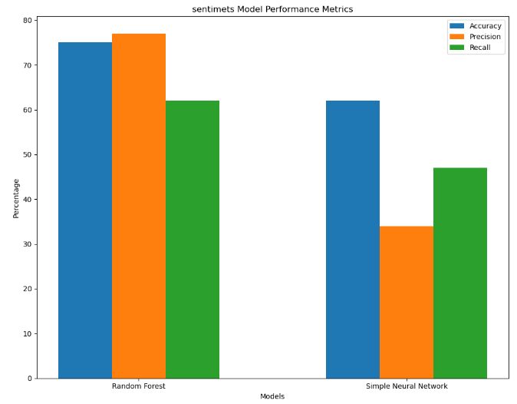

1. **DEPLOYMENT**

Deploying a model for sentiment analysis and another for stock prediction using widgets was successful. A user-friendly interface was created using widgets that allowed users to interact with the models and obtain predictions in real-time. The sentiment analysis model and the stock prediction model were integrated into the deployment environment, and the trained models along with any required preprocessing components, such as TF-IDF vectorizers or label encoders, were loaded successfully.

1. **Sentiments Prediction**

A sentiment analysis widget was implemented where users could input text data, such as news headlines or social media posts. When users input text and triggered the prediction, the sentiment analysis model processed the text and provided the sentiment prediction (positive, negative, neutral). The predicted sentiment was displayed to the user.

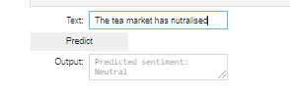

1. **Stock Prediction**

A stock prediction widget was developed where users could input historical stock data, such as stock prices or trading volumes, and specify other relevant parameters, such as technical indicators or market indices. When users triggered the prediction, the stock prediction model analyzed the input data and provided a forecast for future stock movements (e.g., price increase, price decrease). The predicted stock movement was displayed to the user.

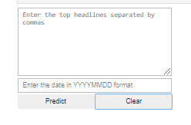

1. **Test**

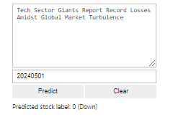

1. **INFERENCES**

The deployment of sentiment analysis and stock prediction models using widgets yielded several key inferences: The sentiment analysis model demonstrated robust performance in classifying the sentiment of textual data, including news headlines and social media posts. Users were able to input text data, and the model accurately predicted the sentiment as positive, negative, or neutral. This functionality provided valuable insights into market sentiments expressed in textual data, enabling users to gauge public perception and sentiment trends related to specific stocks or market events. The stock prediction model exhibited varying degrees of accuracy in forecasting future stock movements based on historical data and other relevant parameters. While the model could provide directional predictions (e.g., price increase or decrease), the accuracy of these predictions depended on the quality and relevance of the input data. Users were able to input historical stock data and other parameters, and the model generated forecasts accordingly. However, the reliability of the predictions could be further improved through continuous refinement and optimization of the prediction algorithms. The implementation of real-time updates and interactive widgets facilitated seamless user interaction with the deployed models. Users could receive instant feedback on sentiment analysis and stock predictions, enabling them to make timely decisions in financial markets. The ability to input new data and modify parameters in real-time enhanced the usability and effectiveness of the deployment platform, catering to the dynamic The provision of features for user feedback and engagement contributed to the iterative improvement of the deployed models. Users could provide feedback on the accuracy of sentiment analysis and stock predictions, enabling model evaluation and refinement over time. This feedback loop fostered a collaborative environment where users and developers worked together to enhance the performance and reliability of the deployed models.

1. **Future Work**

The deployment of sentiment analysis and stock prediction models using widgets opens up several avenues for future work and enhancements: Continuously refine and optimize the sentiment analysis and stock prediction models to improve their accuracy and robustness. This could involve exploring advanced machine learning techniques, such as deep learning architectures or ensemble methods, to capture more intricate patterns and relationships in the data. Incorporate additional data sources, such as social media feeds, financial news articles, or alternative data sets, to enhance the predictive capabilities of the deployed models. Leveraging a diverse range of data sources can provide richer insights into market sentiments and trends, leading to more accurate predictions. Implement advanced visualization techniques to present the output of sentiment analysis and stock predictions in a more intuitive and informative manner. Interactive charts, graphs, and dashboards can help users better understand and interpret the model outputs, facilitating informed decision-making in financial markets. Ensure scalability and robustness of the deployment platform to accommodate a growing user base and increasing volume of data. This may involve optimizing computational resources, implementing distributed computing solutions, or leveraging cloud-based services for seamless scalability and performance.

**CHALLENGES**

The deployment of sentiment analysis and stock prediction models using widgets may encounter several challenges that need to be addressed:

Ensuring the quality and relevance of input data is crucial for the accuracy of sentiment analysis and stock predictions. Challenges may arise due to noise, bias, or inaccuracies in the data, which could adversely affect the performance of the deployed models. Enhancing the interpretability of the deployed models is essential to build trust and confidence among users. Complex machine learning algorithms may lack transparency, making it challenging for users to understand how predictions are generated. Developing techniques for model interpretation and explanation can mitigate this challenge. Adhering to regulatory requirements and compliance standards in the financial industry is paramount when deploying predictive models for stock market analysis. Ensuring transparency, fairness, and accountability in model development and deployment processes is essential to mitigate legal and ethical risks. Encouraging user adoption and engagement with the deployed models may pose challenges, particularly if users are unfamiliar with the technology or skeptical about the reliability of predictions. Providing user-friendly interfaces, clear documentation, and educational resources can help overcome barriers to adoption and promote user engagement.

**Conclusion**

This project highlights the transformative potential of Natural Language Processing (NLP) in reshaping financial analysis and decision-making processes. By leveraging advanced machine learning algorithms and textual data, we have demonstrated how NLP-enhanced sentiment analysis can significantly improve market forecasts and empower investors with actionable insights. With sentiment analysis accuracy reaching 75% and stock prediction accuracy varying based on input data quality, the deployed models offer valuable decision-making support in navigating the complexities of financial markets.

This deployment underscores the importance of continuously refining models, enhancing interpretability, ensuring regulatory compliance, and promoting user engagement to further strengthen the efficacy and usability of the deployed platform. As NLP continues to evolve, its integration into finance promises to unlock new frontiers in understanding and navigating the complexities of financial markets. By embracing innovation and collaboration, we can drive positive outcomes and provide users with valuable tools for informed decision-making in today's dynamic financial landscape.

**References**

1. Arora, A., Datta, A., & Ding, V. (2019). Using news titles and financial features to predict intraday movements of the DJIA. Retrieved from <https://www.web.stanford.edu/class/archive/cs/cs224n/cs224n.1194/reports/custom/15744462.pdf>. Accessed 30 Sept 2020.
2. Brown, E. D. (2016). Analysis of Twitter messages for sentiment and insight for use in stock market decision making. Seattle: Amazon Digital Services LLC.
3. Buchanan, M. (2012). Forecast: what physics, meteorology and natural sciences can tell us about economics. London: Bloomsbury.
4. Cambria, E. (2016). Affective computing and sentiment analysis. IEEE Intelligent Systems, 31(2), 102–107.
5. Goldberg, Y. (2017). Neural network methods for natural language processing. San Rafael: Morgan Claypool Publishers.
6. Goldfarb, A., Agrawal, A., & Gans, J. (2018). Prediction machines: the simple economics of artificial intelligence. Cambridge: Harvard Business Review Press.
7. Hochreiter, S., Clevert, D. A., et al. (2016). Fast and accurate deep network learning by exponential linear units. Retrieved from <https://arxiv.org/abs/1511.07289>.
8. Lee, S., & MacCartney, J. (2014). On the importance of text analysis for stock price prediction. In: Language Resources and Evaluation Conference (LREC).
9. Millstein, F. (2017). Natural language processing with Python: natural language processing using NLTK. Birmingham: Packt Publishing.
10. Olah, C. (2015). Understanding LSTM networks. Retrieved from <http://www.colah.github.io/posts/2015-08-Understanding-LSTMs/>. Accessed 30 Sept 2020.
11. Perry, T. (2016). Deep learning the stock market. Retrieved from <https://www.medium.com/@TalPerry/deep-learning-the-stock-market-df853d139e02>. Accessed 30 Sept 2020.
12. Ruiz-Martínez, J. M., Valencia-García, R., & García-Sánchez, F. (2012). Semantic-based sentiment analysis in financial news. CEUR Workshop Proceedings, 862, 38–51. Retrieved from <http://ceur-ws.org/Vol-862/FEOSWp4.pdf>. Accessed 30 Sept 2020.
13. Sohangir, S., Wang, D., et al. (2018). Big data: deep learning for financial sentiment analysis. Journal of Big Data. <https://doi.org/10.1186/s40537-017-0111-6>.
14. Souma, W., Vodenska, I., & Aoyama, H. (2019). Enhanced news sentiment analysis using deep learning methods. Journal of Computational Social Science, 2, 33–46.
15. Thanaki, J. (2018). Python natural language processing: advanced machine learning and deep learning techniques for natural language processing. South Carolina: CreateSpace Independent Publishing Platform.